SECURITY LAB REPORT
Active Directory — AS-REP Roasting Assessment
Authorized Isolated Laboratory Assessment
DATE  25 October 2026 | CLASSIFICATION  TLP:AMBER
DOMAIN  corp.local (NetBIOS: CORP) | DOMAIN CONTROLLER  DC01 — 192.168.56.101
TESTING SYSTEM  Kali Linux | PRIMARY TOOL  Impacket GetNPUsers v0.13.0.dev0

1. Executive Summary
This engagement validated whether the test account asrep-test was susceptible to AS-REP roasting while Kerberos pre-authentication was disabled, then verified that remediation closed the exposure. An initial request against the domain controller DC01 (192.168.56.101) returned valid AS-REP ticket material, confirming the account was exploitable for offline password guessing. The account setting DoesNotRequirePreAuth was subsequently corrected, and a retest confirmed that the same request no longer returns ticket material. No evidence of credential recovery or domain compromise was observed at any point in this assessment.

2. Objective
Validate whether a targeted Active Directory account returns AS-REP ticket material when Kerberos pre-authentication is disabled, apply remediation, and confirm through retesting that the exposure is closed.

3. Scope and Environment
Domain | corp.local (NetBIOS: CORP)
Domain Controller | DC01 — 192.168.56.101
Testing System | Kali Linux
Tool | Impacket GetNPUsers v0.13.0.dev0
Test Account | asrep-test

4. Method and Results

4.1 Connectivity and Name Resolution
Kali successfully pinged the domain controller with 0% packet loss. TCP/88 (Kerberos) was open, and dc01.corp.local resolved to 192.168.56.101. The inverse-host-lookup warning shown by nc did not prevent the port check from succeeding.
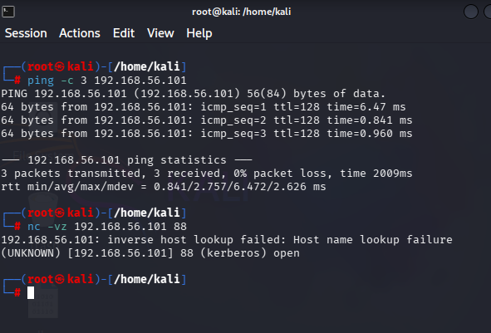
Figure 1. Kali connectivity checks: ping succeeds and Kerberos TCP/88 is open.

4.2 Initial AS-REP Request
The following command was issued against the domain controller with no prior credentials:
python3 GetNPUsers.py 'corp.local/asrep-test' -dc-ip 192.168.56.101 \
-dc-host DC01.corp.local -request -no-pass
The request returned a value beginning with $krb5asrep$23$asrep-test@CORP.LOCAL, confirming that AS-REP ticket material was returned for the asrep-test account. This material is sufficient for an attacker to attempt offline password guessing against the account without triggering a failed-logon event on the domain controller.
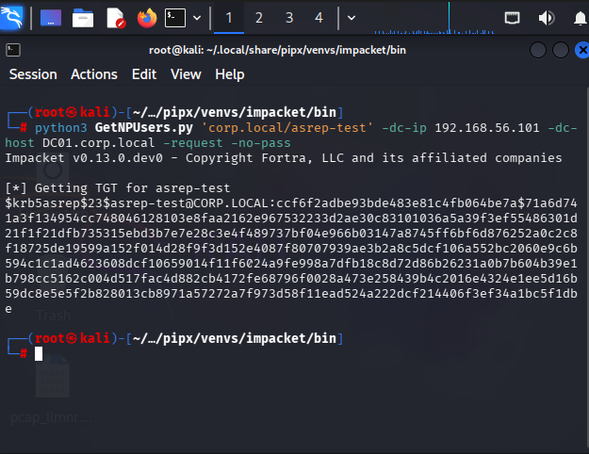
Figure 2. Initial GetNPUsers request returns AS-REP material for asrep-test.

4.3 Remediation
Kerberos pre-authentication was re-enabled for the account, then the setting was verified:
Set-ADAccountControl -Identity "asrep-test" -DoesNotRequirePreAuth $false
Get-ADUser "asrep-test" -Properties DoesNotRequirePreAuth |
Select-Object SamAccountName, Enabled, DoesNotRequirePreAuth
The verification output confirms that the account remained enabled (Enabled = True) and that DoesNotRequirePreAuth was set to False, meaning Kerberos pre-authentication is once again required for this account.
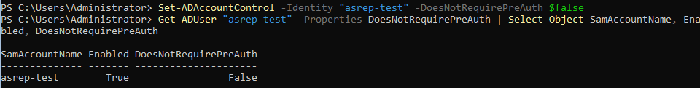
Figure 3. PowerShell remediation command and verification: Enabled = True, DoesNotRequirePreAuth = False.

4.4 Retest
The GetNPUsers request was repeated from Kali against the same target following remediation. The tool obtained a ticket-granting ticket (TGT) for the account but reported that asrep-test no longer has UF_DONT_REQUIRE_PREAUTH set, and no AS-REP ticket material was returned. This confirms that the remediation was effective and the account is no longer exploitable for AS-REP roasting.
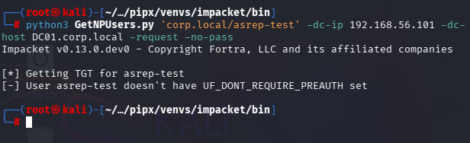
Figure 4. Post-remediation retest: GetNPUsers no longer returns AS-REP ticket material for asrep-test.

5. Finding
Finding: AS-REP ticket material was returned for the asrep-test account during the initial test, as a result of Kerberos pre-authentication being disabled. Such material can be used for offline password-guessing attacks. No evidence was observed that a password was recovered or that the domain was compromised.
Risk: Medium — contingent on the strength of the account password and whether the exposure is detected before an offline attack succeeds.
Remediation: Kerberos pre-authentication should be enabled for all accounts unless a documented, reviewed exception requires otherwise. Account settings should be audited periodically, and all accounts should use strong, unique passwords to limit the impact of any AS-REP material that is obtained.
Status: Resolved. The account setting was corrected and verified; a post-remediation retest confirmed the account is no longer exploitable (see Section 4.4).

6. Conclusion
This assessment documented the full lifecycle of the finding: connectivity and reconnaissance (Figure 1), confirmation of the AS-REP roasting exposure (Figure 2), remediation of the underlying account setting (Figure 3), and a successful post-remediation retest (Figure 4) showing the exposure is closed. No further action is required for this account beyond the periodic auditing recommended above.

A. Appendix A — Command Reference
Purpose | Command
Connectivity check | ping -c 3 192.168.56.101
Port check (Kerberos) | nc -vz 192.168.56.101 88
Name resolution | getent hosts dc01.corp.local
AS-REP request | python3 GetNPUsers.py 'corp.local/asrep-test' -dc-ip 192.168.56.101 -dc-host DC01.corp.local -request -no-pass
Remediate account | Set-ADAccountControl -Identity "asrep-test" -DoesNotRequirePreAuth $false
Verify setting | Get-ADUser "asrep-test" -Properties DoesNotRequirePreAuth | Select-Object SamAccountName, Enabled, DoesNotRequirePreAuth

